Nandani Rauniyar
CH.SC.U4CE24261

DAA-Assignment 2
(SORTING TECHNIQUES)

1) Write a C program to do bubble sort.

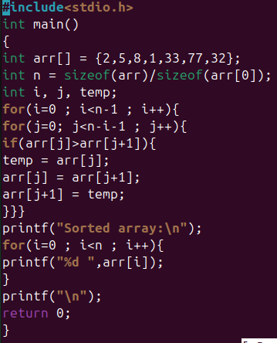
Output:
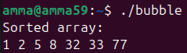

2) Write a C program to do insertion sort.

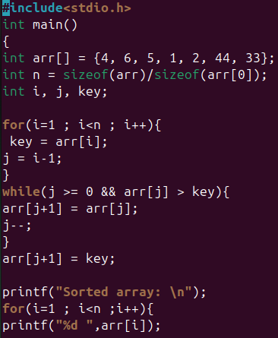
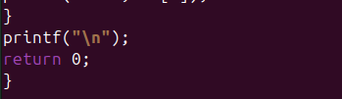

Output:
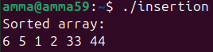

3)Write a C program to do selection sort.

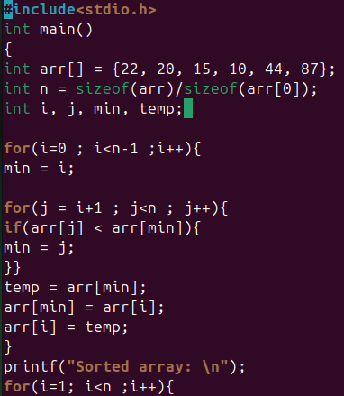
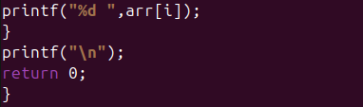
Output:
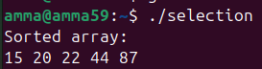

4)Write a C program to do bucket sort.

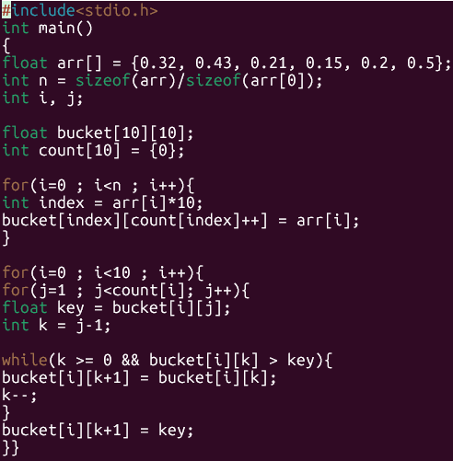
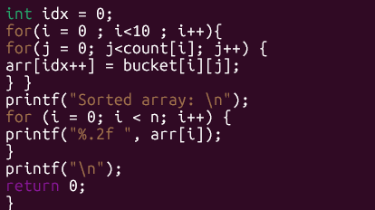
Output: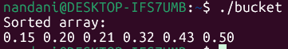

5) Write a C program to do Quick sort.

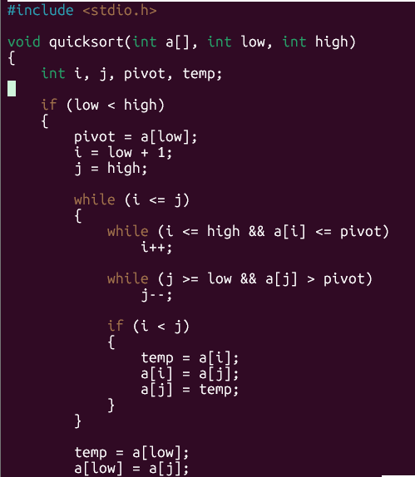
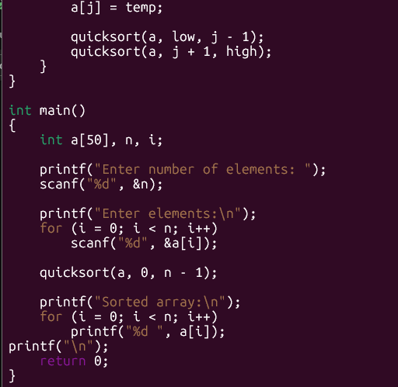

Output:
